Illuminat3D

# What is our project

Our project is Illuminat3D and it participates in the NASA Space Apps Challenge 2021. More specifically it participates in the challenge “When light curves throw us curve balls", and aims to provide a light curve of every 3D mode, with some initial input parameters like the rotation axis of the object and its albedo.

To calculate the brightness of an object at any moment of its rotational phase, we are using an innovative combination of physics, mathematics and informatics. Based on a theoretical model for the reflectance, called Lambertian reflectance, we constructed a method to calculate the whole irradiance (W/m^2) detected by an observer at some distance from an object. That is done via the separation of the object in elementary surfaces, then the calculation of the irradiance of each elementary surface, and lastly adding all the individual irradiances. This procedure has been implemented using python.

The most significant benefit is the freedom that it provides to the users. This approach does not require a 3d representation of the model and therefore does not consume graphical processing resources. Our goal was to create a tool which can be used by anyone in order to explore the relation between the several available parameters and the produced light curve.

There are also ambitions about the use of this project to develop a reverse engineering algorithm in order to give clues about the shape of an asteroid based on the given light curve. There are several parameters that the user can assign: source-observer angle, albedo, initial rotation axis and initial rotation angle, basic rotation axis and the number of points for the plot. Also, a user-friendly, explanatory and educative GUI is designed so that every user of every background can use this program.

# Physics Background

An observer with a telescope that collects light with a lens of area $a$ is positioned at a point in space, at a distance $d$ from a flat surface of area $A,$ which he has an unobstructed view of at an angle of $ω$ from the normal to the surface. The flat surface is illuminated by the sun with approximately parallel light, with an irradiance $I$ (measured with units of $\frac{W}{m^{2}}$) at an angle of $θ$ from the normal of the surface. The surface has an albedo of $ρ$ between 0 and 1. We assume a perfectly matte, Lambertian surface and an orthographic view of the surface due to the large distance between it and the observer.

Now that we have described the scenario, the size to calculate from these given values is the irradiance at the observer’s telescope. We will first take a look at the surface.  
Due to its angle to the incident irradiance, the effective area of the surface (it’s projection to the plane which is perpendicular to the travel direction of light coming from the sun) is geometrically calculated to be $A_{s}=A*\cos{ω}$ therefore, it receives a wattage of $W_{in}=A*I*\cos{ω}$ 
 of which, due to its albedo, it reflects $W_{out}=W_{in}*ρ$ with a radiant intensity in accordance to Lambert’s law. Bringing all that together, we have $$W_{out}=A*I*\cos{ω}*ρ (1)$$ 
According to Lambert’s law, the radiant intensity $I_{rad}$ (measured with units of $\frac{W}{sr}$) is proportional to the cosine of the angle $θ$ to the normal of the surface and is equal to $I_{rad}=I_{0}\cos{θ}$ where $I_{0}$ is the maximum radiant intensity at the normal to the surface. To calculate $I_{0}$ in terms of power, we need to integrate over the entire half hemisphere and solve for $I_{0}$. This is shown below.

$W_{out}=\int_{0}^{2π}{\int_{0}^{π/2}{I_{0}cosθ*\left(sinθ\right)dθdφ}}=π*I_{0}$ therefore $I_{0}=\frac{W_{out}}{π}$ (2)

It’s worth noting that sinθ is the determinant of the Jacobian matrix for the unit sphere.  
  
In order to calculate the power that reaches the telescope, one must integrate the radiant intensity over the solid angle that describes the telescope’s lens from the perspective of the surface. So,

$$W_{t}=\int{I_{0}cosθdΩ}$$ Here we remove $I_{0}cosθ$ from the integral since we assumed an orthographic view and therefore a constant θ. We are aware that if the θ were really constant, it would be impossible to have a solid angle above 0 but it is necessary in order to continue calculations. The error it produces is infinitesimal and it can be ignored. Therefore, we have $W_{t}=I_{0}cosθΩ$ 
 where Ω can be calculated as $Ω=\frac{α}{d^{2}}$  
Putting all that together with (1) and (2), we have $W_{t}=\frac{A*I*cosφ*ρ*cosθ*a}{π*d^{2}}$ from which we need to deduct the irradiance simply by dividing by the area of the telescope $a$.  
In conclusion, the irradiance at the observer will be $L=\frac{A*I*cosφ*ρ*cosθ}{π*d^{2}}$

Irradiance from several different surfaces can be added linearly. Therefore, in an object composed of a number of different flat surfaces, the total irradiance observed will simply be a sum of the irradiance of each composing surface.

# 3D asteroid models

The 3D models are formed by points, in Cartesian coordinates, which are joined together in thriplets and form triangular surfaces, as shown below.

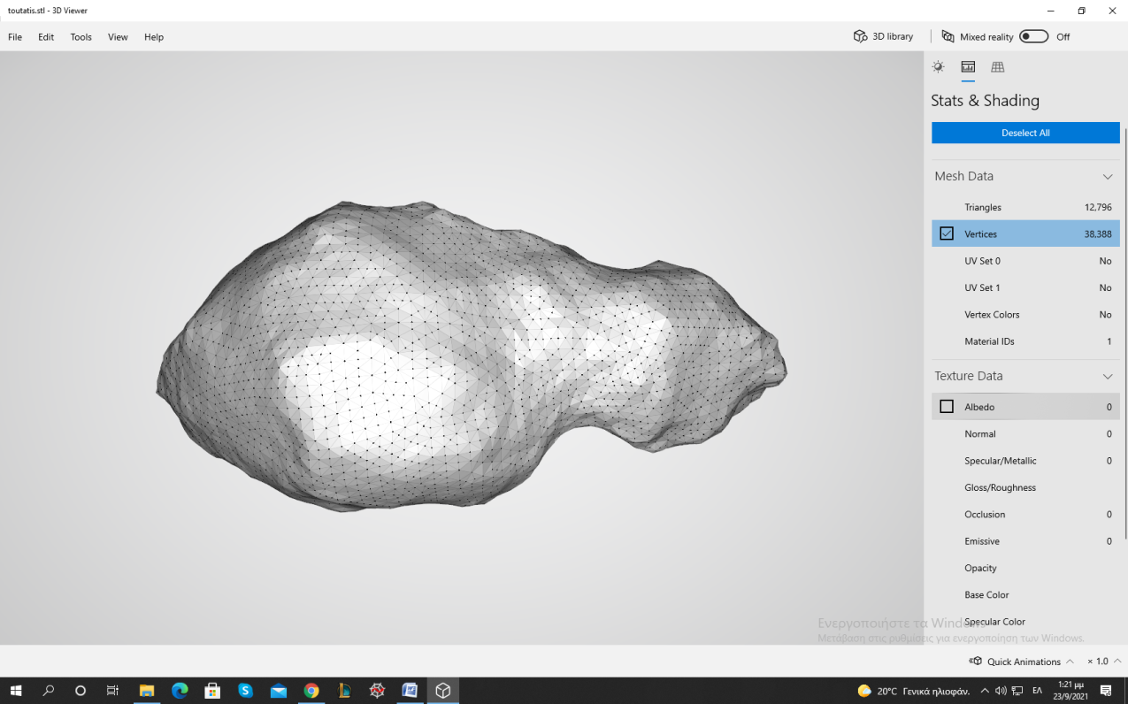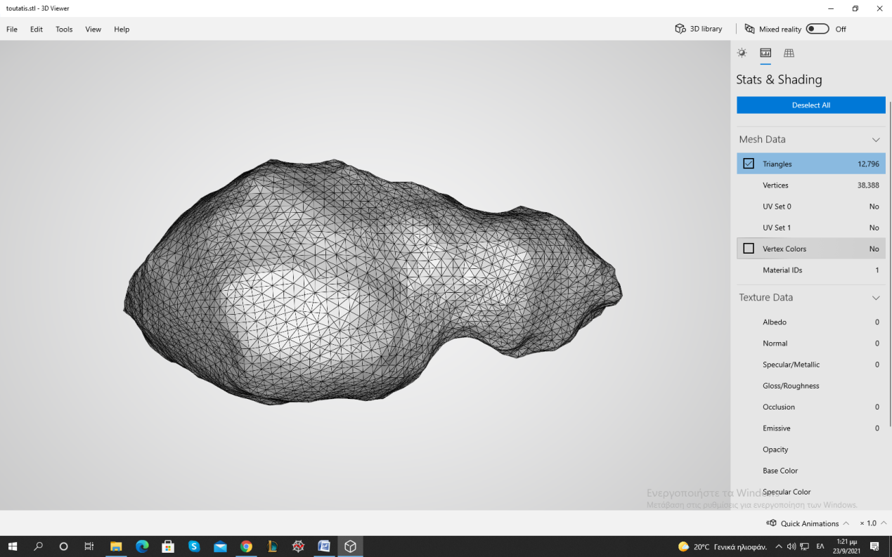

By using the Lambertian law of reflection, and considering the area of ​​surface Ai as each triangular surface of the 3D model, the total irradiance reflected by an asteroid can be calculated.



**Αi**

This approach has two problems:

1. non-recognition of viewing surfaces, i.e. which surfaces are in the telescope’s view
2. absence of shading, i.e. which surfaces are in the light source’s view.

Since the lighting in the present problem is parallel and the telescope’s view is orthographic, the two problems are equivalent. The only difference is the direction of the viewer, either referring to the telescope or the source. This equivalence and the solution to the problem are analyzed in the next chapter.

# Finding the viewing surfaces

Let three objects: the light source S, the asteroid A and the observer O. Each object is represented macroscopically with a point in 3D space, as their distances are very large. Therefore these three points form a plane, let the plane be xy (left figure). The light source forms an angle ω with the observer, of vertex A.

**y**

**x**

**S**

**A**

**O**

**ω**

**x**

**y**

**S**

**A**

**O**

**ω**

Since the election of the xy coordinate system is arbitrary, we can select it so that the observer looks in the -x direction and the angle formed by the light source is equal to the angle formed by the source with the x-axis.

Since the source S and observer O are very far from the asteroid A (orthographic viewing and parallel lighting), the whole surface illuminated by a source of angle ω = 0 will be the same as the surface seen by observer O. Obviously the same is true for every ω. Thus the problems of the previous chapter are equivalent. We still have to find a way to distinguish the surfaces in viewing and not, when looking at the asteroid under a random angle ω.

We go back to the representation of the 3D model with points and triangular surfaces. For the following reasoning, the one-to-one (“1-1”) correspondence of a triangle with a single point is necessary. This is easily done by using their centroids, let them be the points ${\vec{P}}_{i}$.

For an arbitrary angle **ω** we know the direction that is formed from the source to the asteroid, let it be a unit vector ${\hat{e}}_{3}$. We set a plane with normal vecto ${\hat{e}}_{3}$ and its point O (0,0,0), and call it plane V (view). The dot product ${\vec{P}}_{i}∙{\hat{e}}_{3}$ will give the distance of the point Pi from the plane V. Then we calculate the coordinates of the points Pi on a new vector basis. That will be the coordinates on the plane V with a starting point O(0,0,0) and the distance from this plane.

Since the source is at the xy plane, one of the basis vectors on the level V is definitely ${\hat{e}}_{1}=\hat{z}$. The second basis vector is being derived directly from the cross product ${\hat{e}}_{2}={\hat{e}}_{3}×{\hat{e}}_{1}$. The coordinates of the points **Pi** in the new basis $\left\{{\hat{e}}_{1},{\hat{e}}_{2},{\hat{e}}_{3}\right\}$ are being directly from the corresponding dot products of ${\vec{P}}_{i}$ with each basis vector (the new base is orthogonal by construction).

All the above was done for two reasons: now there is a measure of the distance of each triangle from the source, i.e. the coordinate ${\hat{e}}_{3}$. By scanning the centroids from the minimum coordinate ${\hat{e}}_{3}$ to the maximum, we sort the triangles depending on their distance from the viewer, increasingly. Having formed an ascending order of the distances, we correspond each centroid to the three points that make up the triangle, let ${\vec{Q}}_{i}$ be points. Following the same procedure with the dot products we find their coordinates in the basis $\left\{{\hat{e}}_{1},{\hat{e}}_{2},{\hat{e}}_{3}\right\}$. By setting the third coordinate to be zero and maintaining the other two, we have found the projection of each point on the V plane.

By using the aforementioned ascending order of the centroids and the correspondence of the points ${\vec{Q}}_{i}$ to them, we project each trinity of points on the plane V and form each new projected triangle.

After the first projection there is only one triangle. In each subsequent projection we check the overlap percentage of the new triangle with the previous ones and save its complementary number (i.e. if the overlap rate is 30% then I save the value 70%). If a triangle has 100% overlap with the previous ones, it means that it is behind them, that is, it is shaded. Having completed the scan, we know every percentage of every surface that the viewer can see. The figure is showing the first steps of this process. The problem is solved.

**V**

To complete the process we need to know the viewing surfaces for both the observer and the source. We follow the same procedure for both of them. To know the surfaces that are illuminated and at the same time seen by the observer, it is enough to multiply the two percentages that correspond to the same triangle. If a triangle is totally illuminated, i.e. it has 100% from the source, but the observer cannot see it, i.e. it has 0% from the observer, then the result is 0 * 1 = 0, i.e. it does not contribute to the final irradiance.